Data Analysis Report

**Introduction**

**Climate Change**

Environmental change alludes to long-haul shifts in temperatures and weather conditions. These movements might be regular, like through varieties in the sun-oriented cycle. In any case, since the 1800s, human activities have been the principal driver of climate change, fundamentally because of consuming non-renewable energy sources like coal, oil, and gas.

The unrestricted development of greenhouse gases is now raising the earth’s temperature. The outcomes of this include melting glaciers, floods, adverse weather conditions, and shifting seasons. The rapid climatic changes, together with the worldwide growth in population especially in urban areas, raise worries of food insecurity.

Agriculture is incredibly helpless against climatic change. Higher temperatures, in the long run, diminish yields of critical crops while at the same time promoting weed and vermin proliferation. Changes in rain cycles increase the probability of short-run crop failures and consequently decline in food production in the long run. In spite of the fact that there will be gains in certain harvests in certain locales of the world, the general effects of climate change on agribusiness negatively, undermine worldwide food security.

**Findings from the Data**

Data and variables

A world bank dataset with variables pertaining to environmental changes, population, agriculture, forestry, and fishing was used it investigate the presence of relationships, trends, and other statistics pertaining to these variables. The data is a time series with annual records from 1960 to 2020. Among all the countries of the world, Brazil, Japan, and United States were compared to the world records on the same variables. These variables include:

1. Urban population
2. Agriculture, forestry, and fishing, value added (% of GDP)
3. CO2 emissions from solid fuel consumption (% of total)
4. CO2 emissions from liquid fuel consumption (% of total)

Descriptive statistics.

Descriptive statistics are critical in explaining the distribution of variables in terms of measures of central tendencies and also measures of dispersion. The mean, median, and standard deviation given in the Table 1 below are calculated from available data (there were missing values) ranging from 1960 to 2020.

Table 1: Descriptive statistics

|  |  |  |  |
| --- | --- | --- | --- |
| Variable | median | mean | std |
| Brazil | | | |
| Brazil Urban_pop | 1.1E+08 | 1.1E+08 | 48472042 |
| Brazil Solid_CO2 | 39442.25 | 33569.71 | 21276.48 |
| Brazil Liquid_CO2 | 150592.7 | 166418.6 | 82119.44 |
| Brazil Agric_gdp | 8.370881 | 8.364797 | 3.750228 |
| Japan | | | |
| Japan Urban_pop | 95496650 | 94111698 | 17132428 |
| Japan Solid_CO2 | 277331.5 | 292000.6 | 98905.55 |
| Japan Liquid_CO2 | 585388.9 | 531410 | 167296.5 |
| Japan Agric_gdp | 1.123918 | 1.261144 | 0.255597 |
| United State | | | |
| United States Urban_pop | 1.88E+08 | 1.97E+08 | 44413816 |
| United States Solid_CO2 | 1626050 | 1568979 | 375836.1 |
| United States Liquid_CO2 | 2099024 | 2058767 | 315342.4 |
| United States Agric_gdp | 1.115257 | 1.099231 | 0.125499 |
| World | | | |
| World Urban_pop | 2.27E+09 | 2.41E+09 | 9.98E+08 |
| World Solid_CO2 | 8781871 | 8876940 | 3122208 |
| World Liquid_CO2 | 8534485 | 8066238 | 2024479 |
| World Agric_gdp | 4.146988 | 5.368043 | 2.126151 |

**Trend of urban population growth since 1960 to 2020.**

Globally, there has been a drastic increase in the number of people living in urban areas. In 2010, 51.6% lived in metropolitan regions and by 2020, the portion of metropolitan population expanded to 56.2%. It is by and large higher in the developed countries (79.2% in 2020) than in the developing nations (51.6%) (*Total and urban population*. UNCTAD Handbook of Statistics 2021. (n.d.)).

From the analysis, We can also see a strong upward trend in the population living in the urban areas, for the three countries and also the world from 1960 to 2020

Figure 1: Urban population 1960 to 2020

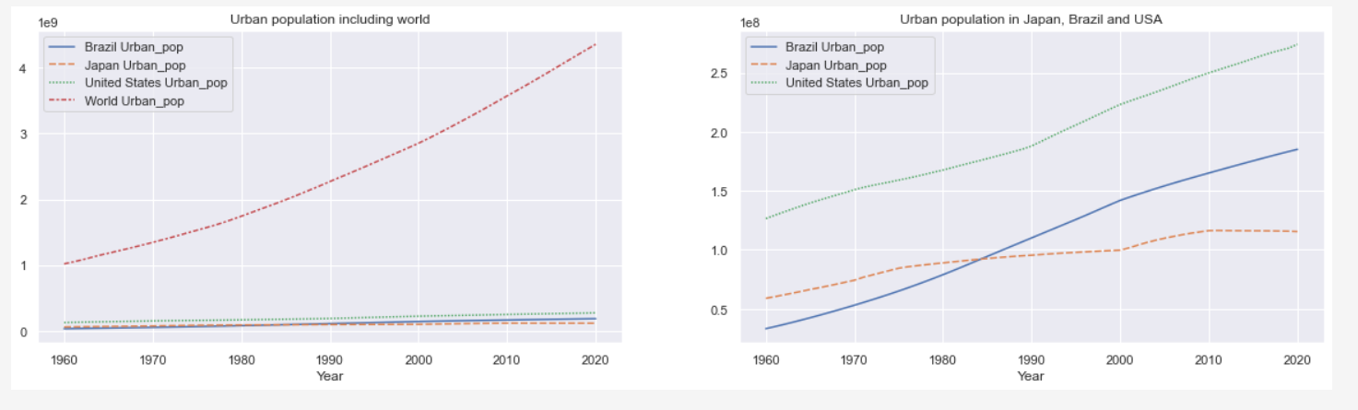

**Trend in the amount of CO2 Emission due to solid fuel combustion**

From the line plots shown below, there has been a general increase in the amount of CO2 produced from solid combustible fuel energy, in Brazil, Japan, and the United States.

Figure 2: CO2 produced from solid combustible fuel energy

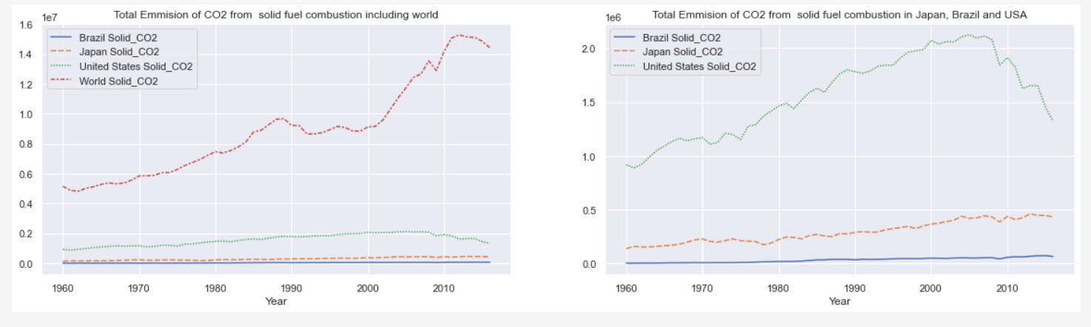

**The trend in the amount of CO2 Emission due to liquid fuel combustion**

As shown in the figure below, there has been a general increase in the amount of CO2 from combustible liquid fuels globally. The United States and Japan have experienced the same growth but in an irregular manner. Brazil has experienced a steady increase in the level of greenhouse gas over these years.

Figure 3: CO2 produced from liquid combustible fuel energy

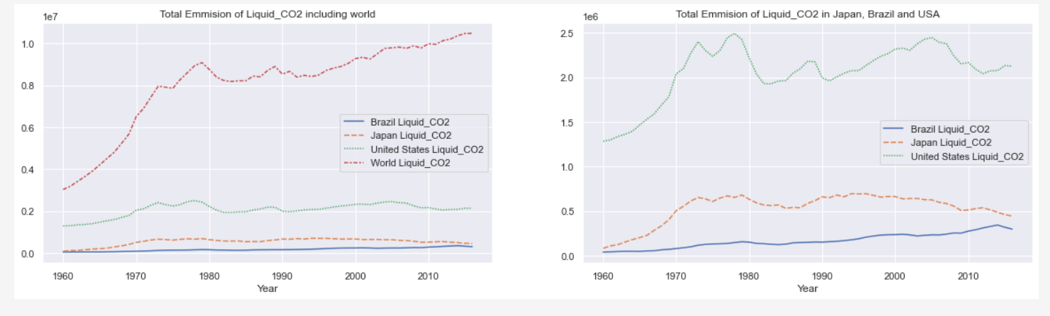

**Trend in the Agriculture, forestry, and fishing, value added (% of GDP) from 1960 to 2020.**

From the figure below, there has been a general decrease in the % agriculture, forestry, and fishing value contributed to GDP globally and in the three selected countries.

Figure 4: Value % agriculture, forestry, and fishing contributed to GDP

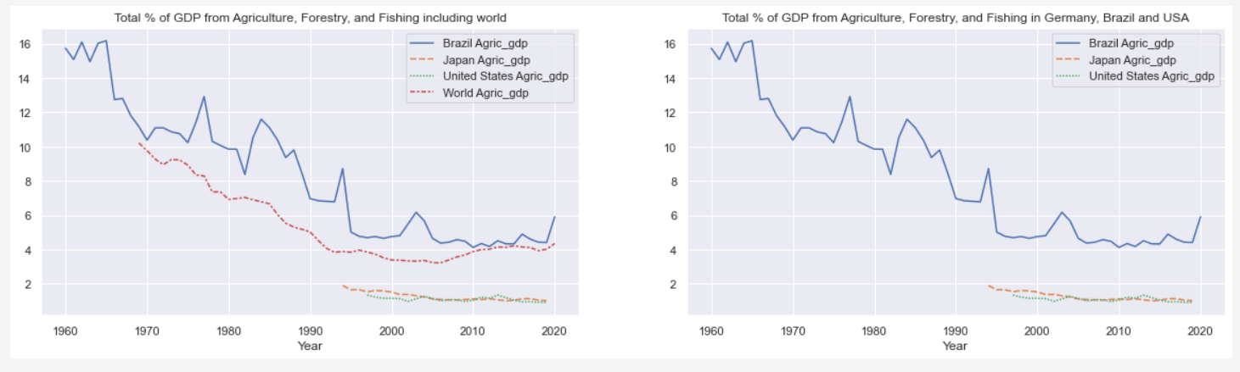

**Correlations between urban population, Emission of CO2, and production in Agriculture, Forestry, and Fishing.**

According to Lv et al (2019) urbanization and growth of the urban population positively affected CO2 discharges because of its expansions in street and air transportation; in any case, the CO2 emanations from rail routes and water transportation were altogether adversely connected with urbanization. In this analysis, a similar relationship was found between the urban population and CO2 emissions from both solid and liquid fuels.

Further, Ayyildiz & Erdal (2021) says that a rapid increase in the level of CO2 influences climate change which has an effect on the production of agricultural produce. This analysis also proved a negative correlation between agriculture, forestry, and fishing value % contributed to GDP. Figure 5 and 8 shows a negative correlation between the percent value of agricultural, fishing, and forestry to GDP and the emission of carbon dioxide from liquid and solid fuels.

Figure 5: Brazil Scatter plots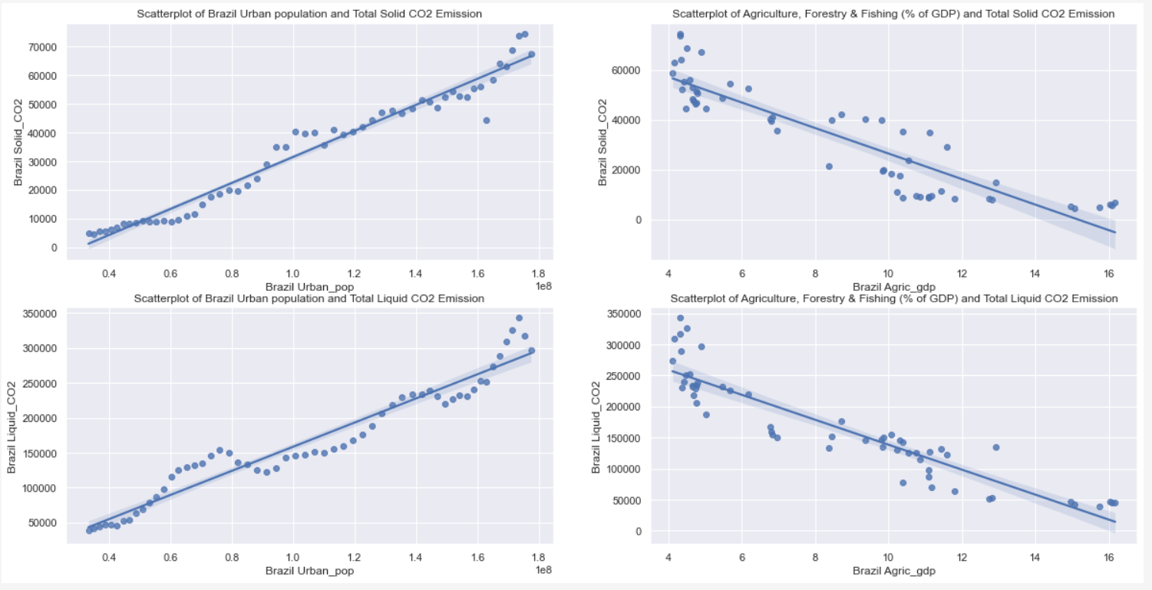

Figure 6: Japan Scatterplots

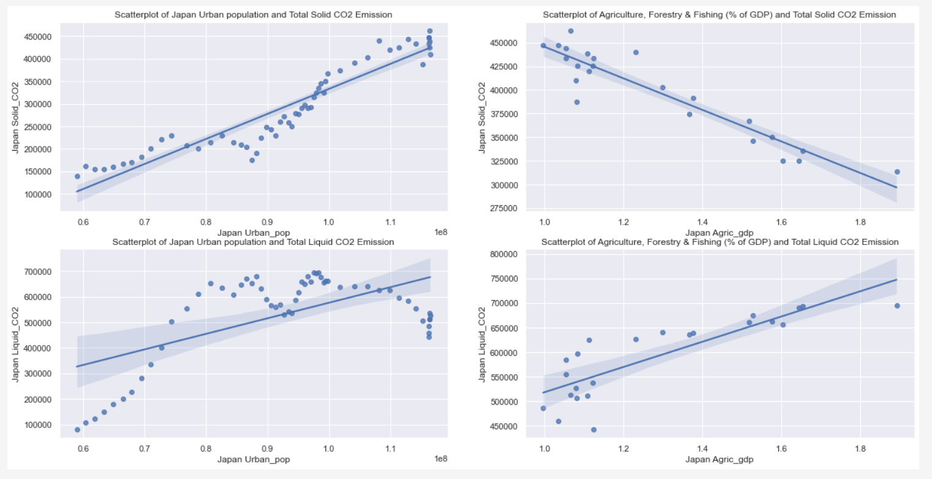

Figure 7: United States scatterplots

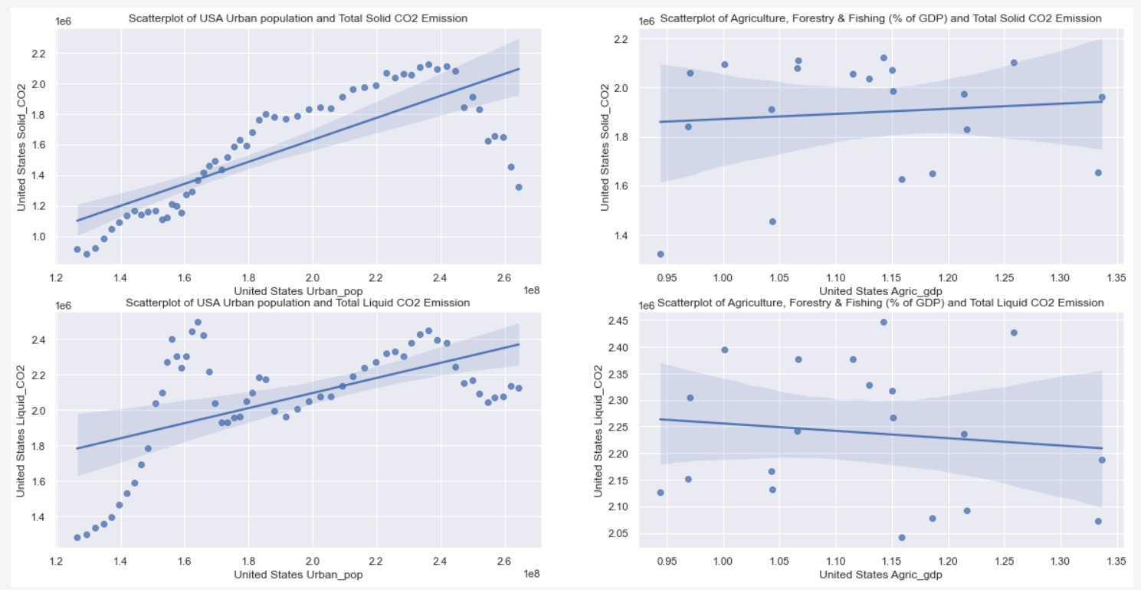

Figure 8: World Scatterplots

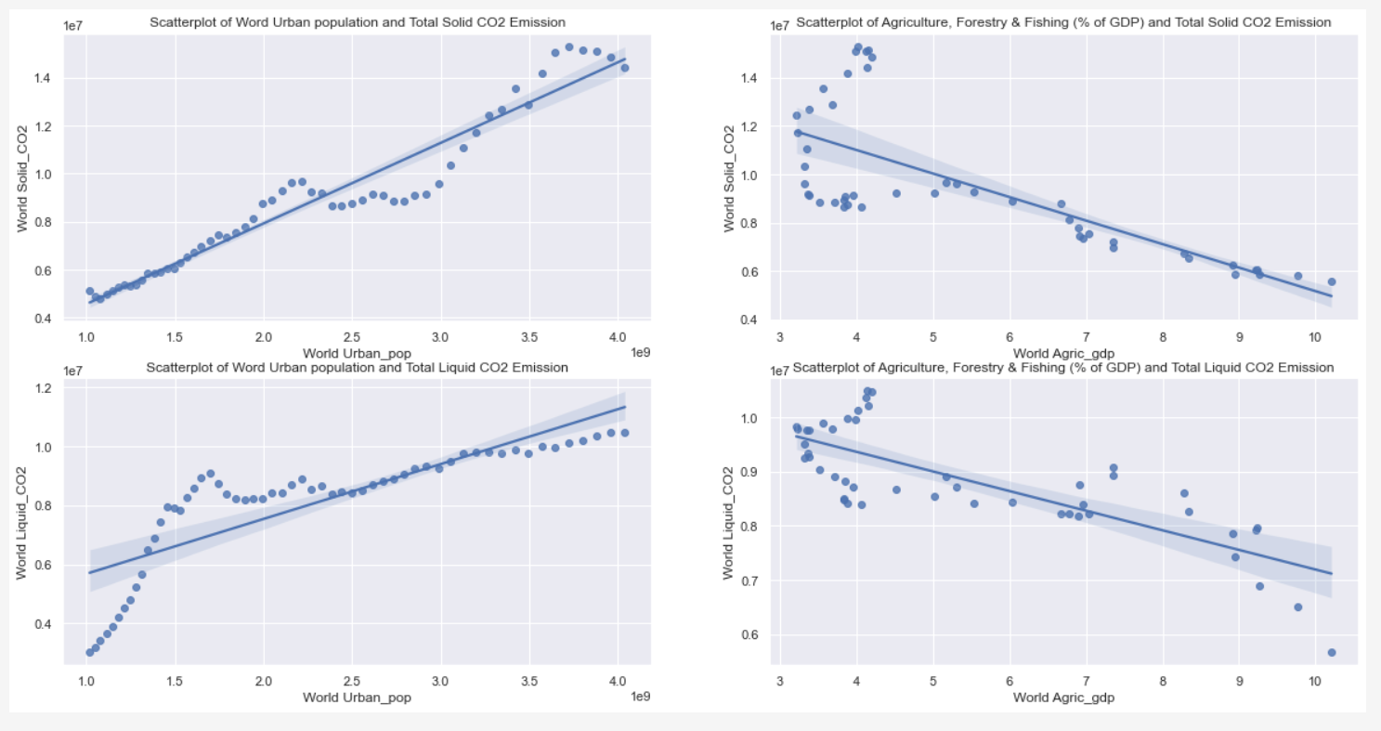

Figure 9: Correlation matrix heatmap

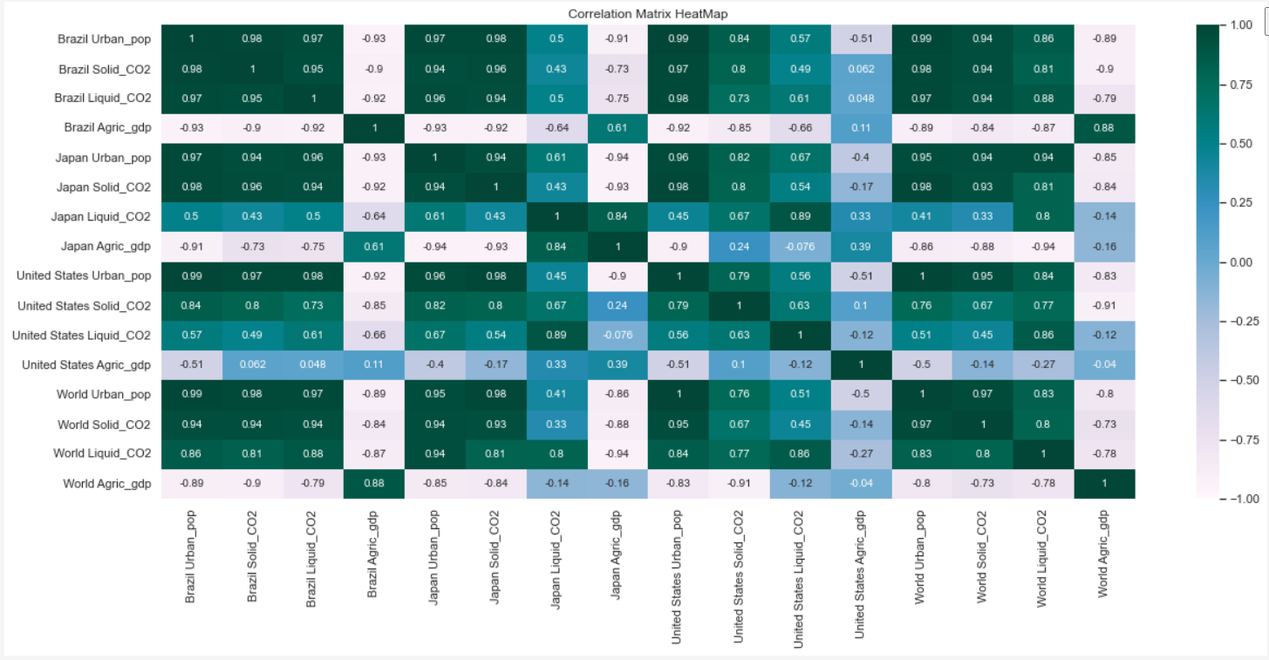

**Conclusion**

In conclusion, we have seen that the urban population has seen a general increase over the years, and has a positive correlation with the amount of greenhouse gases emitted into the air. Also from the line plots, we can see that production of agricultural, forestry, and fishing production has had a general decrease in Brazil and globally. On a global scale, an increase in the amount of CO2 has been associated decrease in the production of agricultural, fishing and forestry produce.

References

Ayyildiz, M., & Erdal, G. (2021). The relationship between carbon dioxide emission and crop and livestock production indexes: a dynamic common correlated effects approach. *Environmental Science and Pollution Research*, *28*(1), 597-610.

Lv, Q., Liu, H., Yang, D., & Liu, H. (2019). Effects of urbanization on freight transport carbon emissions in China: Common characteristics and regional disparity. *Journal of Cleaner Production*, *211*, 481-489.

*Total and urban population*. UNCTAD Handbook of Statistics 2021. (n.d.). Retrieved June 20, 2022, from https://hbs.unctad.org/total-and-urban-population/#:~:text=Urbanization%20continues,world%20(51.6%20per%20cent).